Tower Server

🧱 What is a Tower Server?
# Source: Chatgpt (GPT-5-Mini) at [1/16/2026]
A Tower Server is a standalone physical server that looks similar to a desktop PC tower, but it’s built with server-grade components and is designed to run business applications, store data, or host services like websites or email.
📌 In simple terms: it's a server that stands upright like a regular computer, ideal for small businesses or home labs.

Tower Server images
# Source: Windows ScreenShots at [1/16/2026]
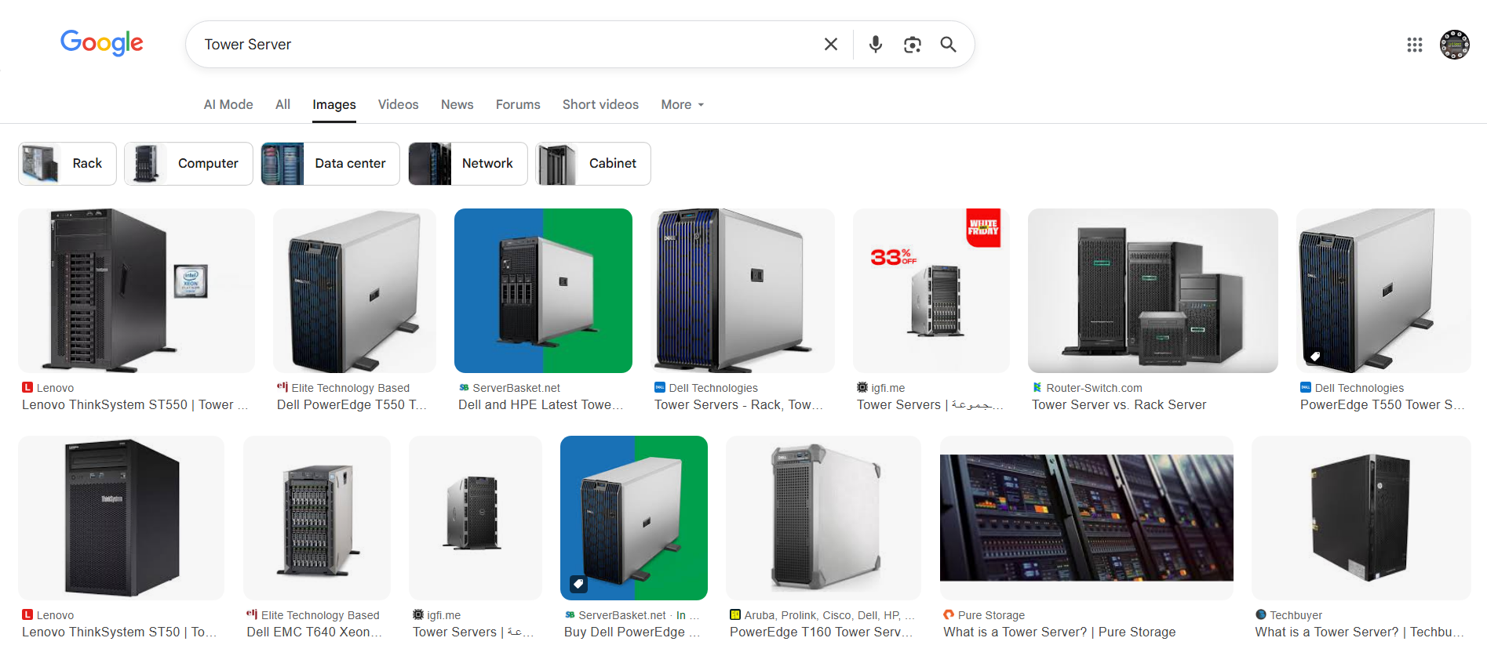

🧩 Key Characteristics of Tower Servers
# Source: Chatgpt (GPT-5-Mini) at [1/16/2026]
Feature | Description
🧠 Shape | Upright, boxy — similar to a desktop computer
🛠️ Standalone | Doesn’t require a rack — runs on its own
🔌 Power Supply | Standard power plug — no special data center infrastructure needed
📦 Upgradable | Has internal space for adding more drives, memory, or PCIe cards

✅ Common Use Cases
# Source: Chatgpt (GPT-5-Mini) at [1/16/2026]
Use Case | Why Tower Server?
🏠 Home lab | Easy to use, quiet, and expandable
🧑‍💼 Small business | Affordable server-grade performance
📁 File storage | Acts as a file or backup server
📧 Email or web hosting | Hosts services without complex setup

🛠️ Example Tower Server Models
# Source: Chatgpt (GPT-5-Mini) at [1/16/2026]
Model Name | Manufacturer | Description
HP ProLiant ML110 | HP | Entry-level tower for SMBs
Dell PowerEdge T40 | Dell | Quiet, efficient, and affordable
Lenovo ThinkSystem ST50 | Lenovo | Compact, server-grade reliability

🔁 Tower Server vs Other Servers
# Source: Chatgpt (GPT-5-Mini) at [1/16/2026]

Feature | Tower Server | Rack Server | Blade Server
📏 Form Factor | Vertical box | Flat, mounted in rack | Thin, slides into chassis
🛠️ Setup | Easy, plug-and-play | Needs rack & rails | Needs blade enclosure
🧊 Cooling | Internal fans | Rack-based cooling airflow | Shared chassis cooling
💰 Cost | 💲 Low to moderate | 💲💲 Moderate to high | 💲💲💲 High (but dense)
🔧 Upgradability | Good for small upgrades | Often hot-swappable parts | Limited (shared enclosure)

✅ Summary
# Source: Chatgpt (GPT-5-Mini) at [1/16/2026]
Property | Tower Server Details
What is it? | A server in the shape of a standalone PC
Used for | File sharing, backups, hosting, dev/testing
Ideal for | Home users, developers, small offices
Main advantage | Simple, cost-effective, no special setup needed
Main downside | Takes more space than rack servers in large setups

